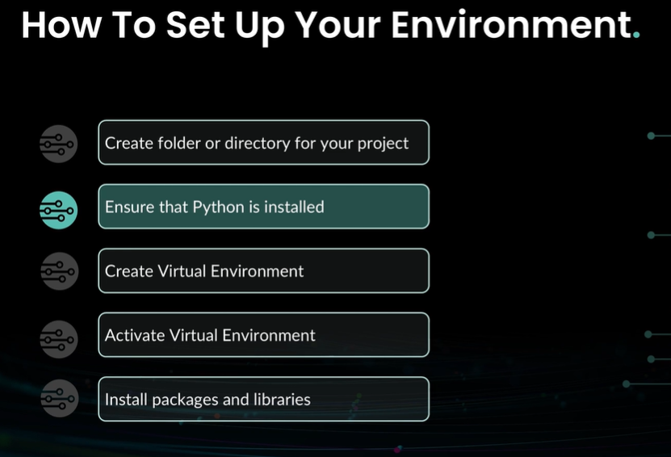

Instructions: How to setup your environment
- Create a folder or directory for your project
- Ensure that you have Python Installed
- Create a virtual environment for your project
- Activate your virtual environment
- Install the require packages and libraries
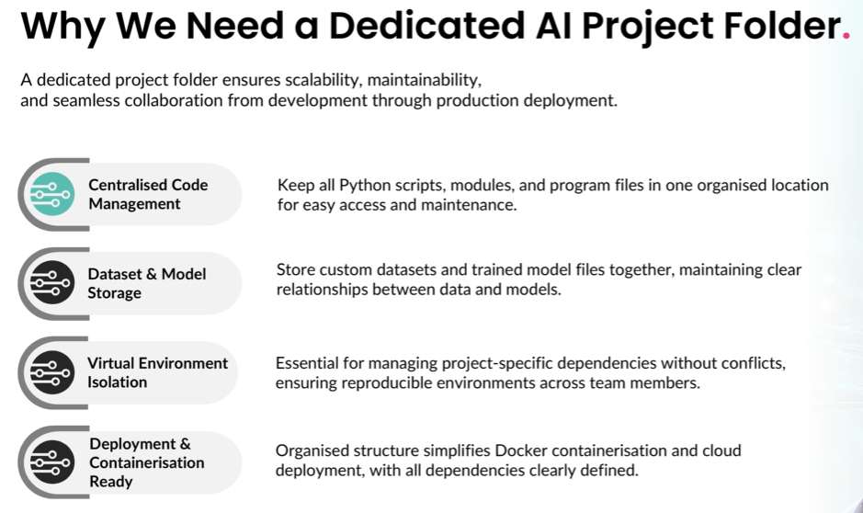
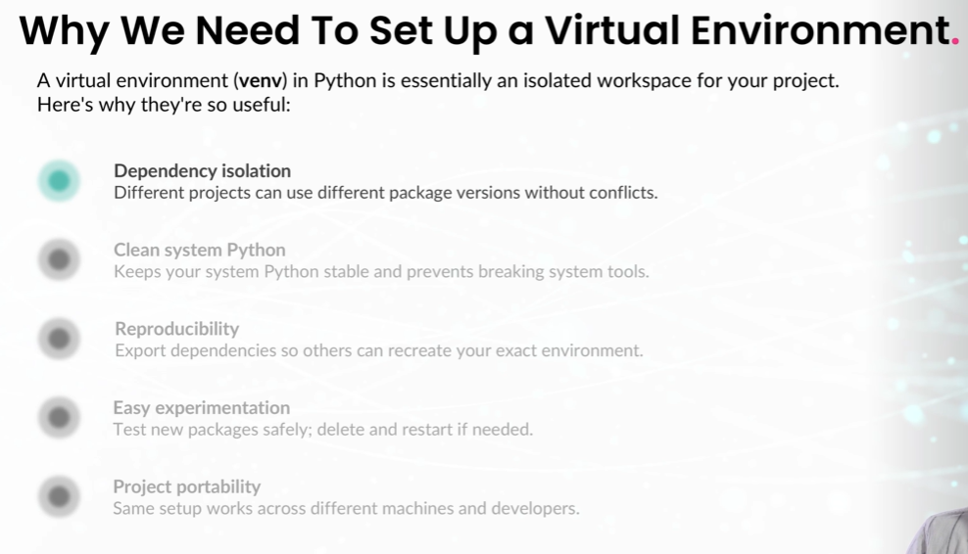
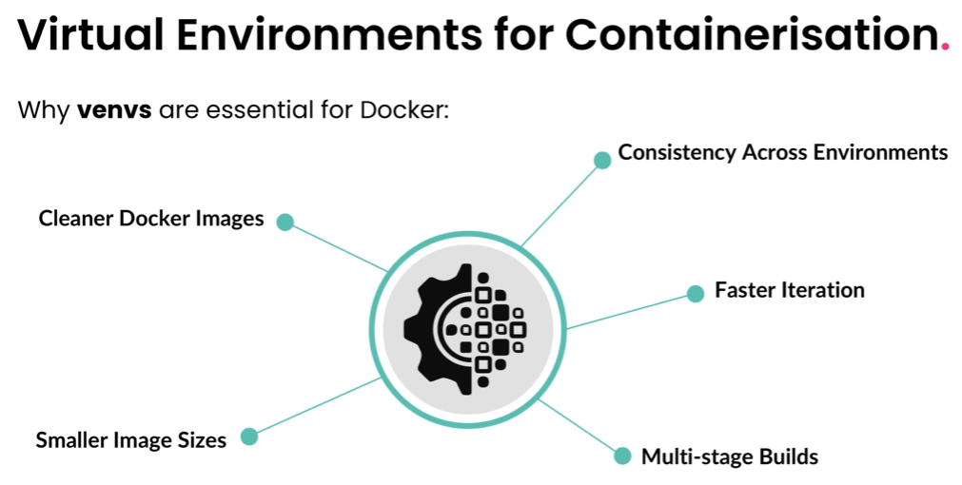

mkdir sentiment_analysis
cd sentiment_analysis
python -m venv venv
venv\Scripts\activate.bat
pip install transformers torch datasets scikit-learn pandas numpy

